Assignment 8
Experiment 8: String Handling (Manual string operations, Library functions)
Instructions:
- Prepare a Word or PDF file containing all the given programs implemented in C language.
- Attach clear screenshots of the output for each program in the same Word/PDF file.
- Upload all C programs to your GitHub repository.
- Provide the GitHub repository link in the space given below.
Name: Kaveen Beniwal
SAP ID: 590032404
Batch: 6
Course: B.Tech. CSE (Sem I)
Subject: Programming in C

Part A: Manual String Operations

- Manual String Length
Write a C program to find the length of a string manually by traversing it until the null character '\0' is encountered. Do not use strlen().
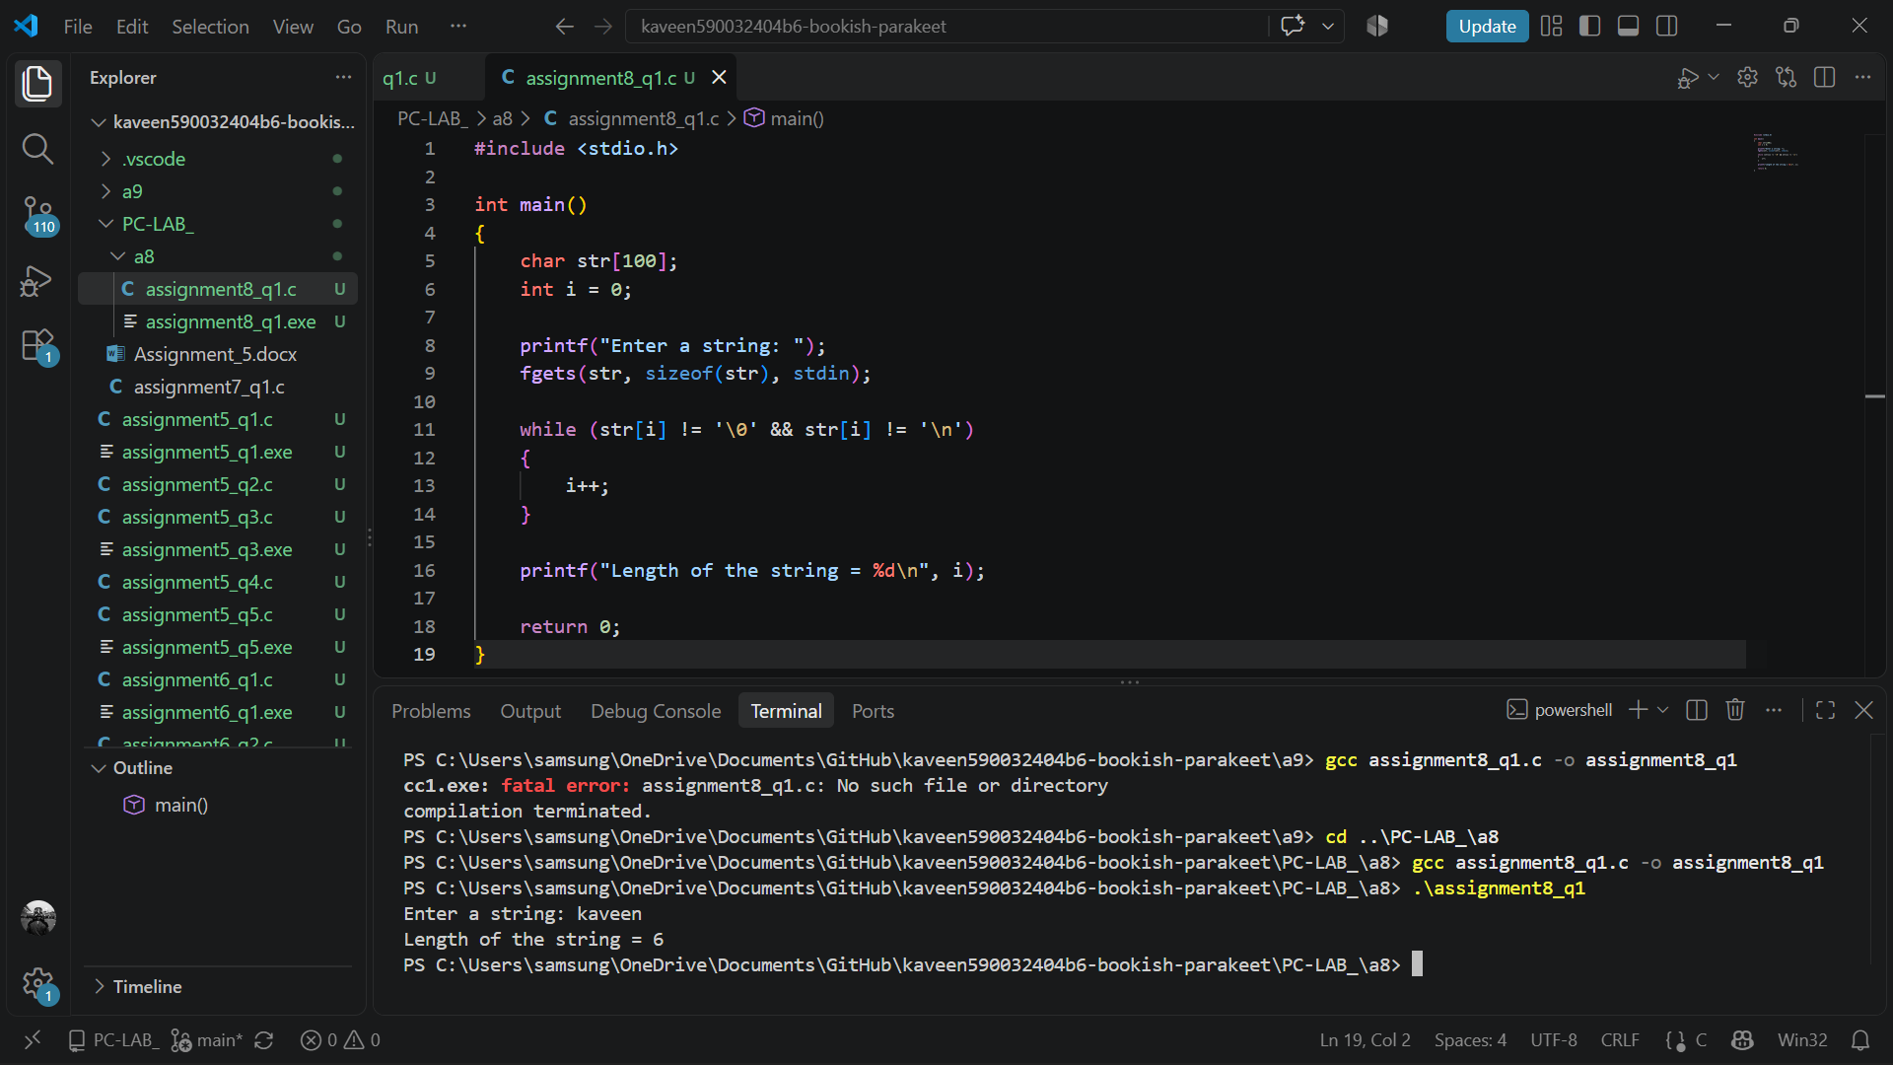

- Manual String Copy
Write a C program to copy one string into another character array manually. Display both the original and copied strings. Do not use strcpy().
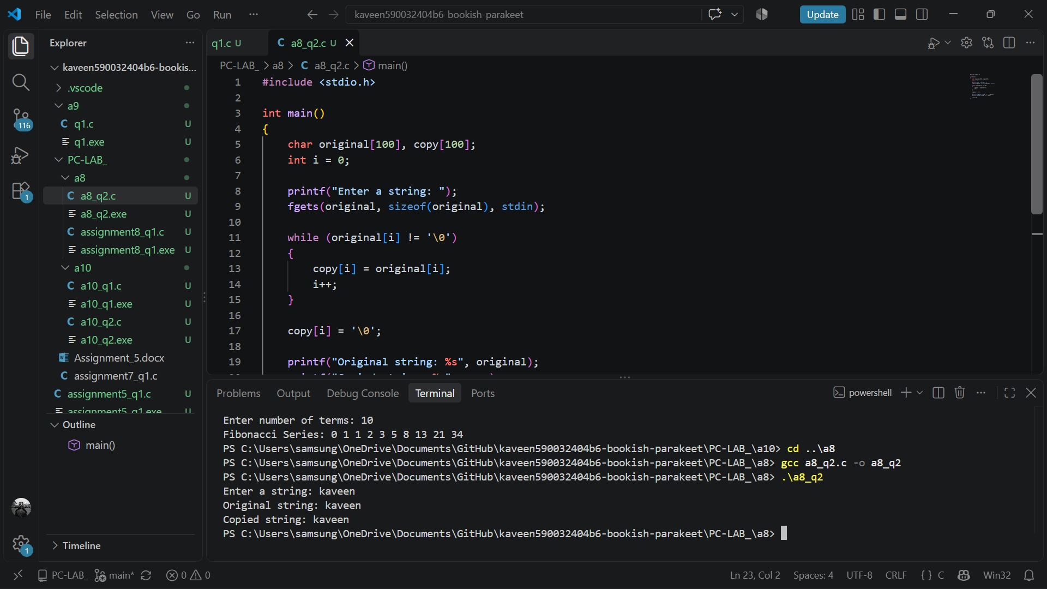
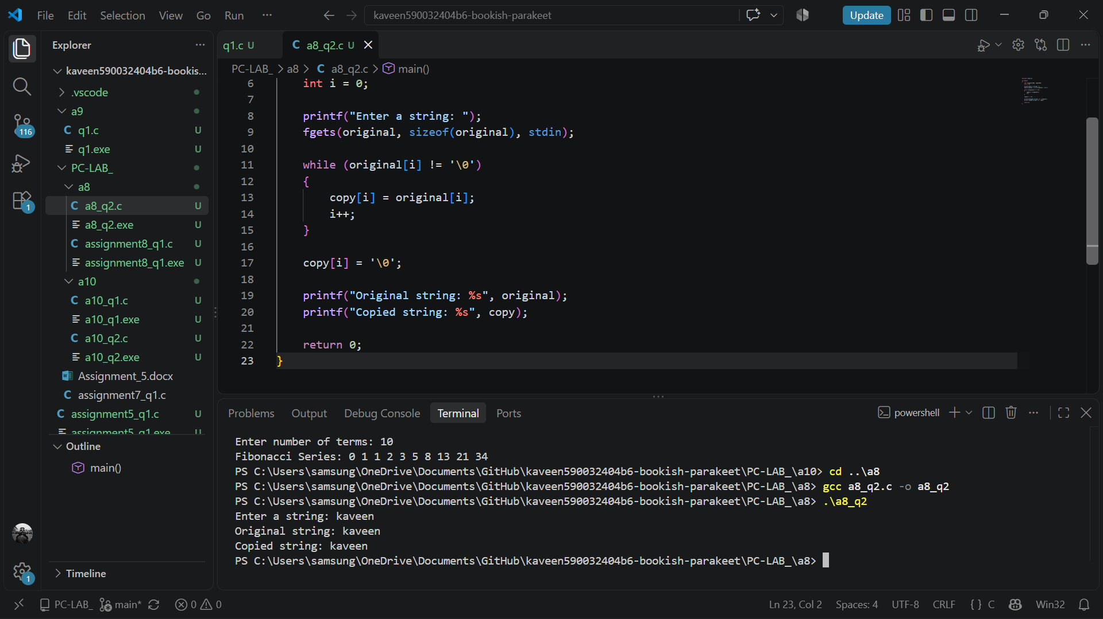

- Manual String Concatenation
Write a C program to concatenate two strings manually. Ensure that the destination array has enough space to hold the combined string. Do not use strcat().
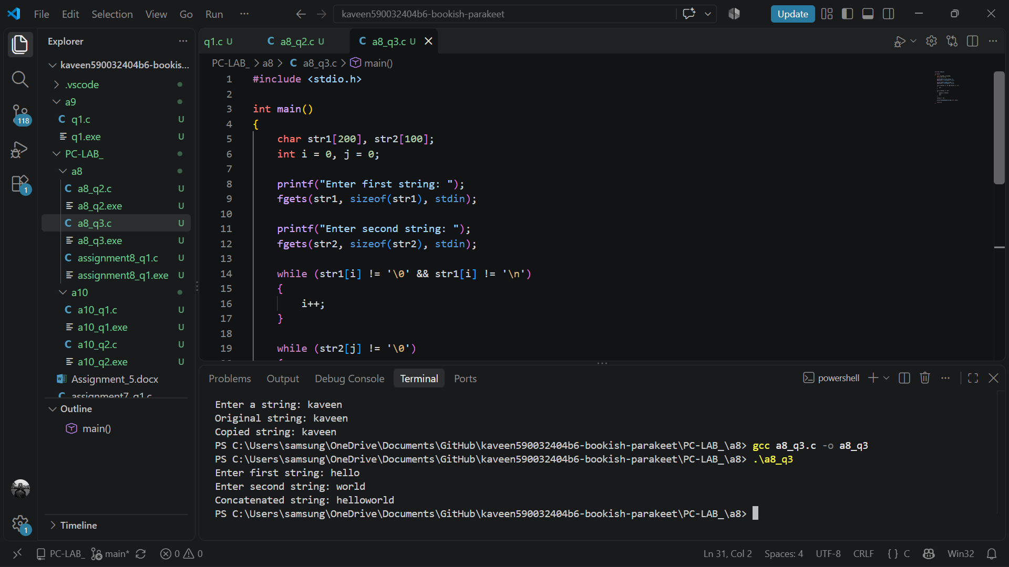
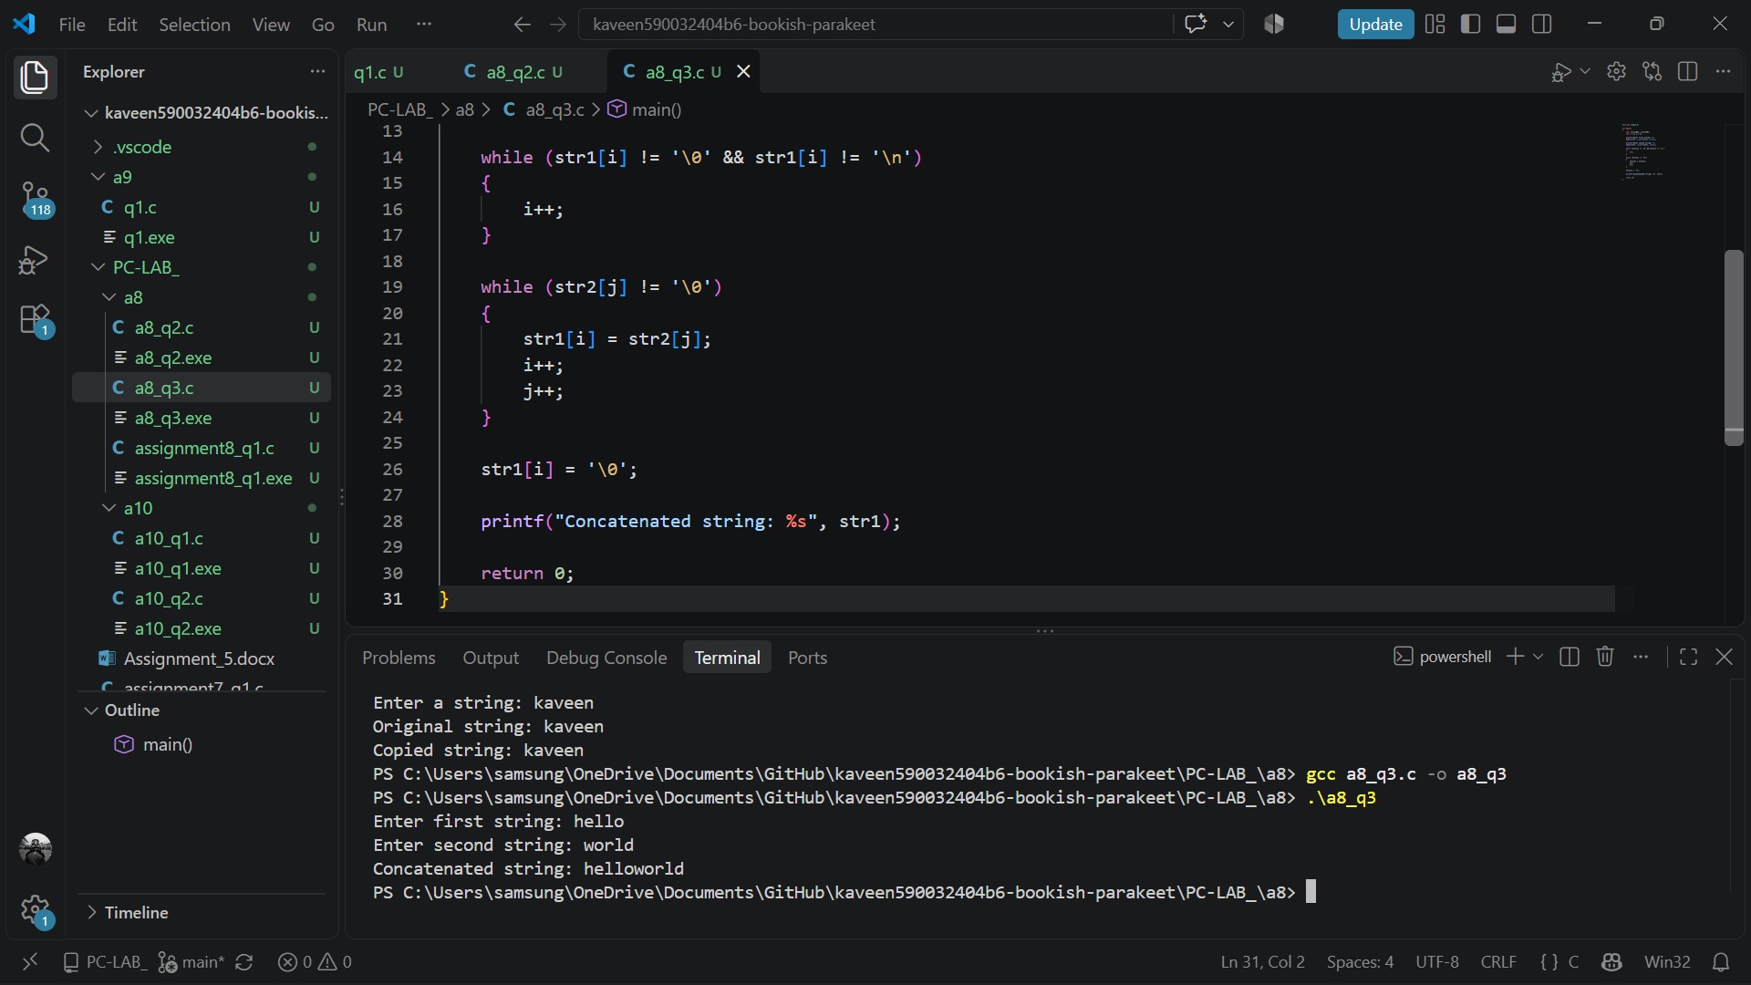

- Palindrome String
Write a C program to determine whether a given string is a palindrome. Ignore differences between uppercase and lowercase letters. For example, Madam should be treated as a palindrome.
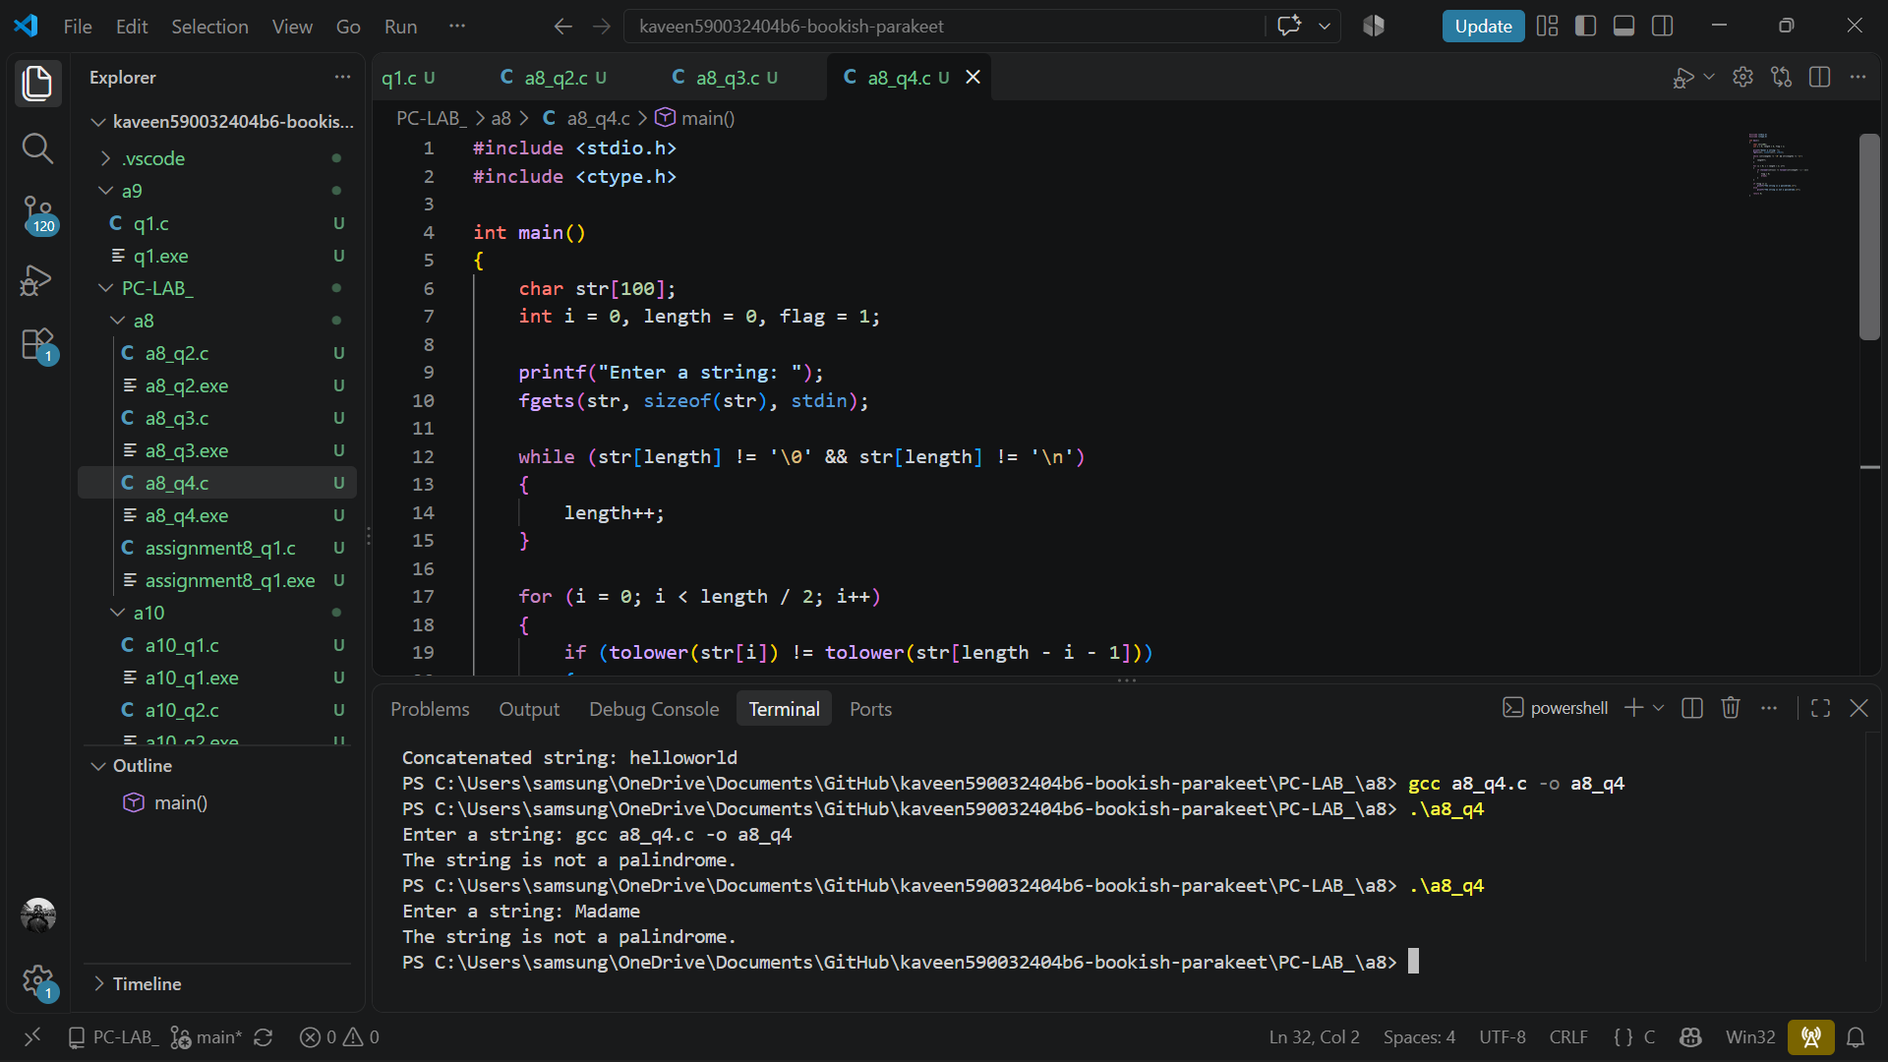
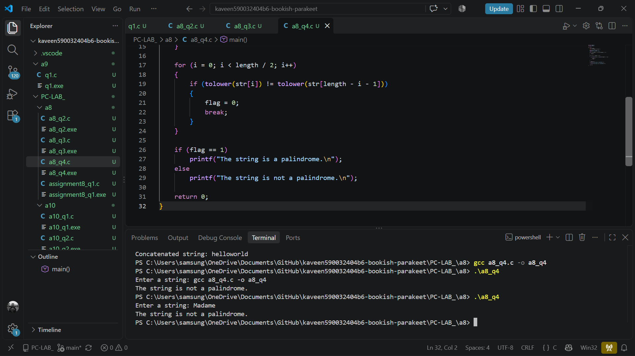

- Character-Frequency Analysis
Write a C program to count the frequency of every character in a string. Treat uppercase and lowercase forms of a letter as the same character, and do not display the same character more than once.
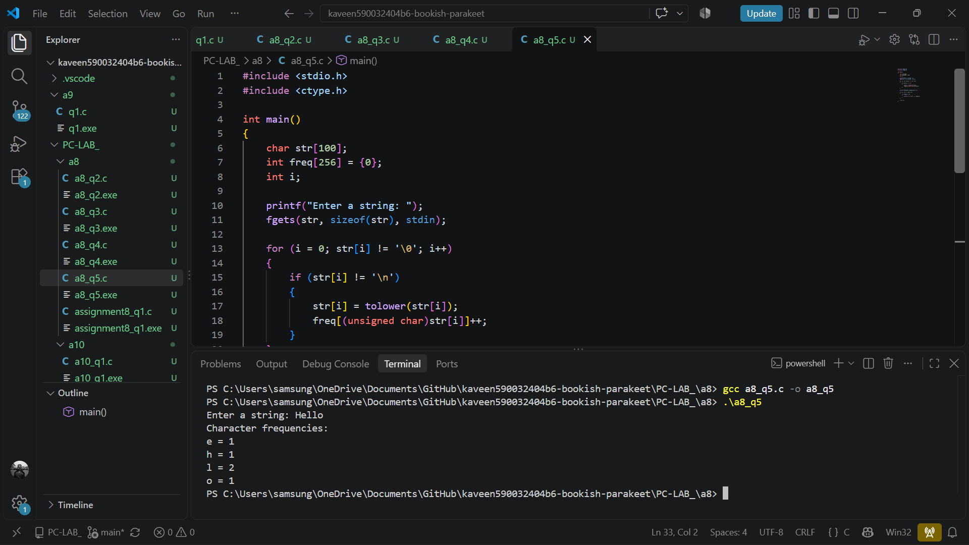
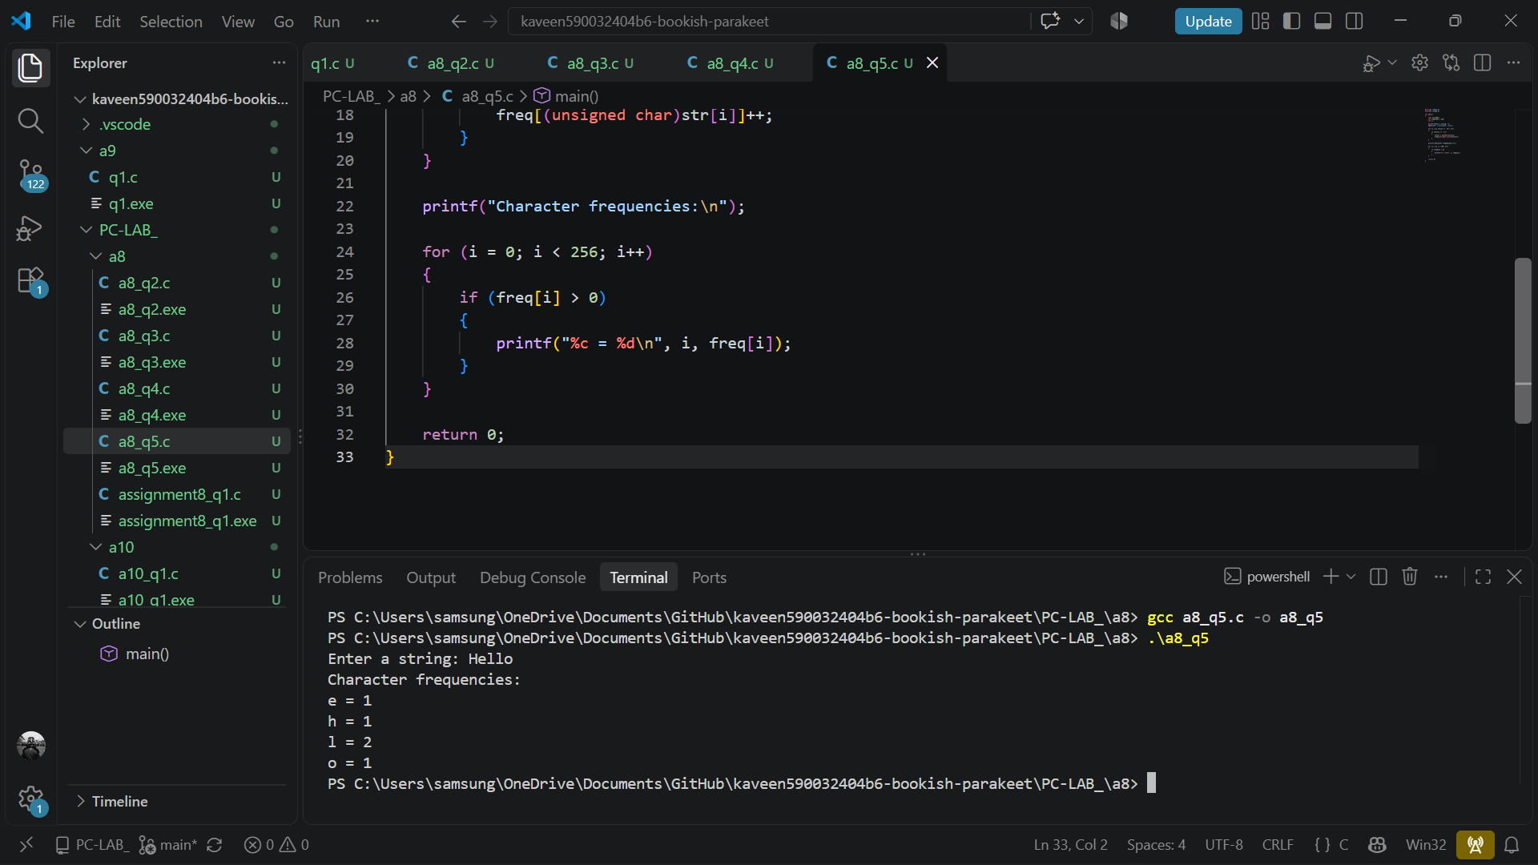

Part B: Using String Library Functions

- String Length and Comparison
Write a C program to input two strings, display their lengths using strlen(), and compare them
using strcmp(). Display whether the strings are equal or which string comes first lexicographically.
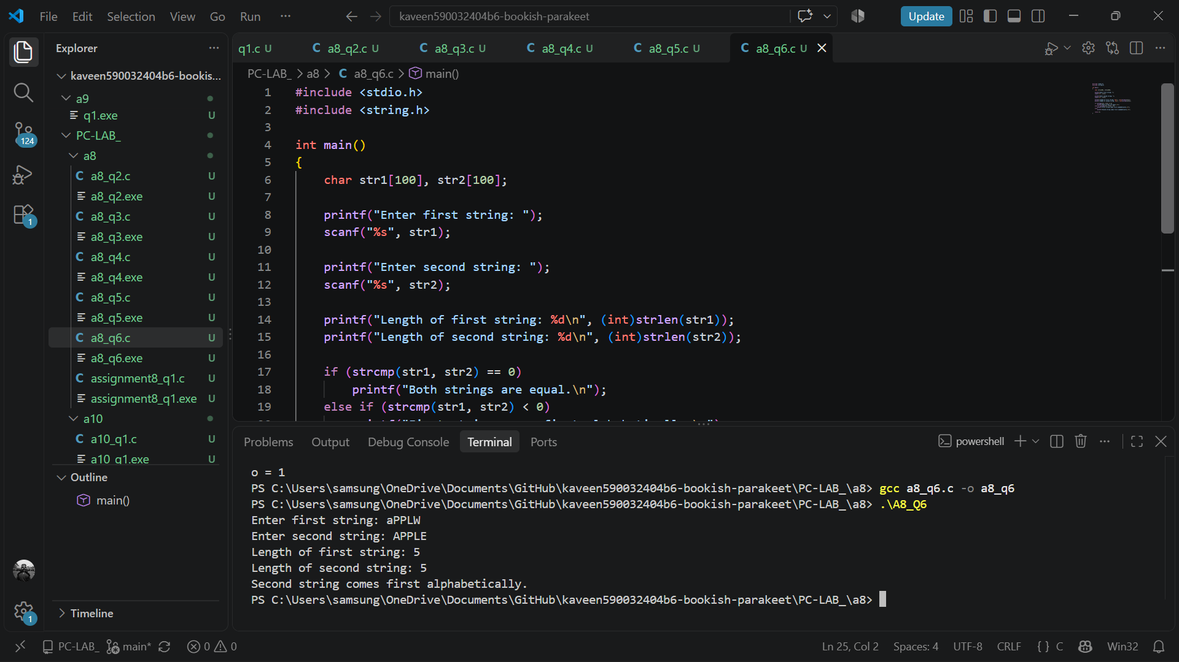
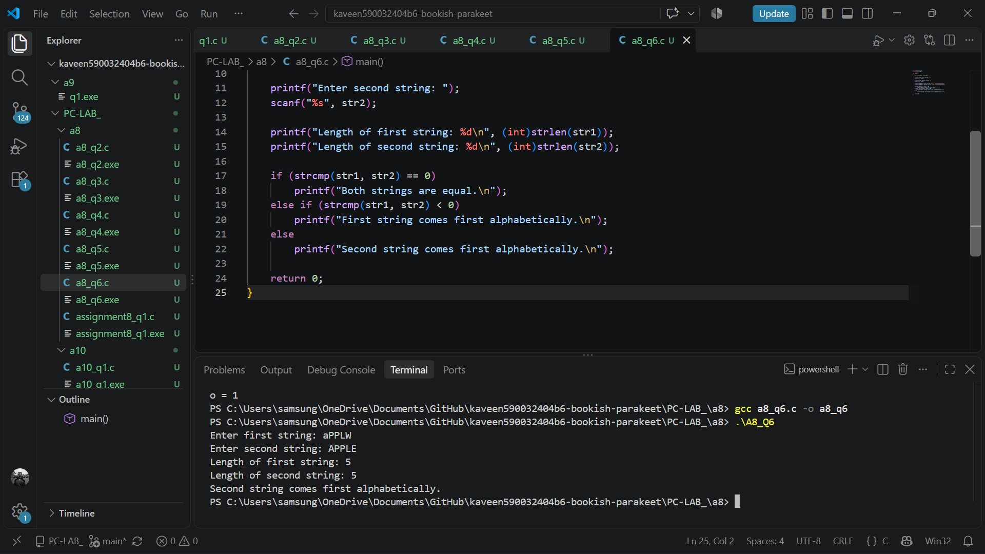

- String Copy and Concatenation
Write a C program to input a first name and a last name. Use strcpy() and strcat() to create and display the complete name with a space between the two names.

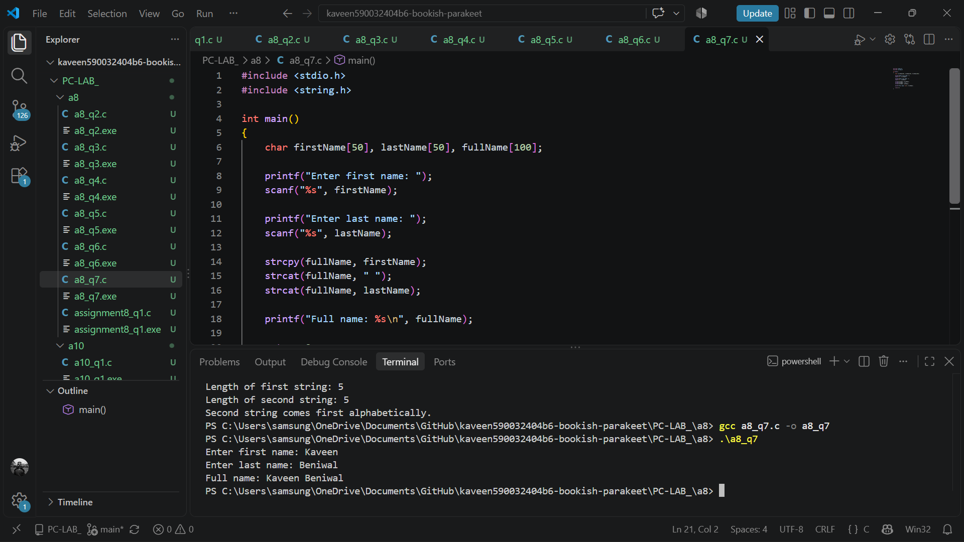
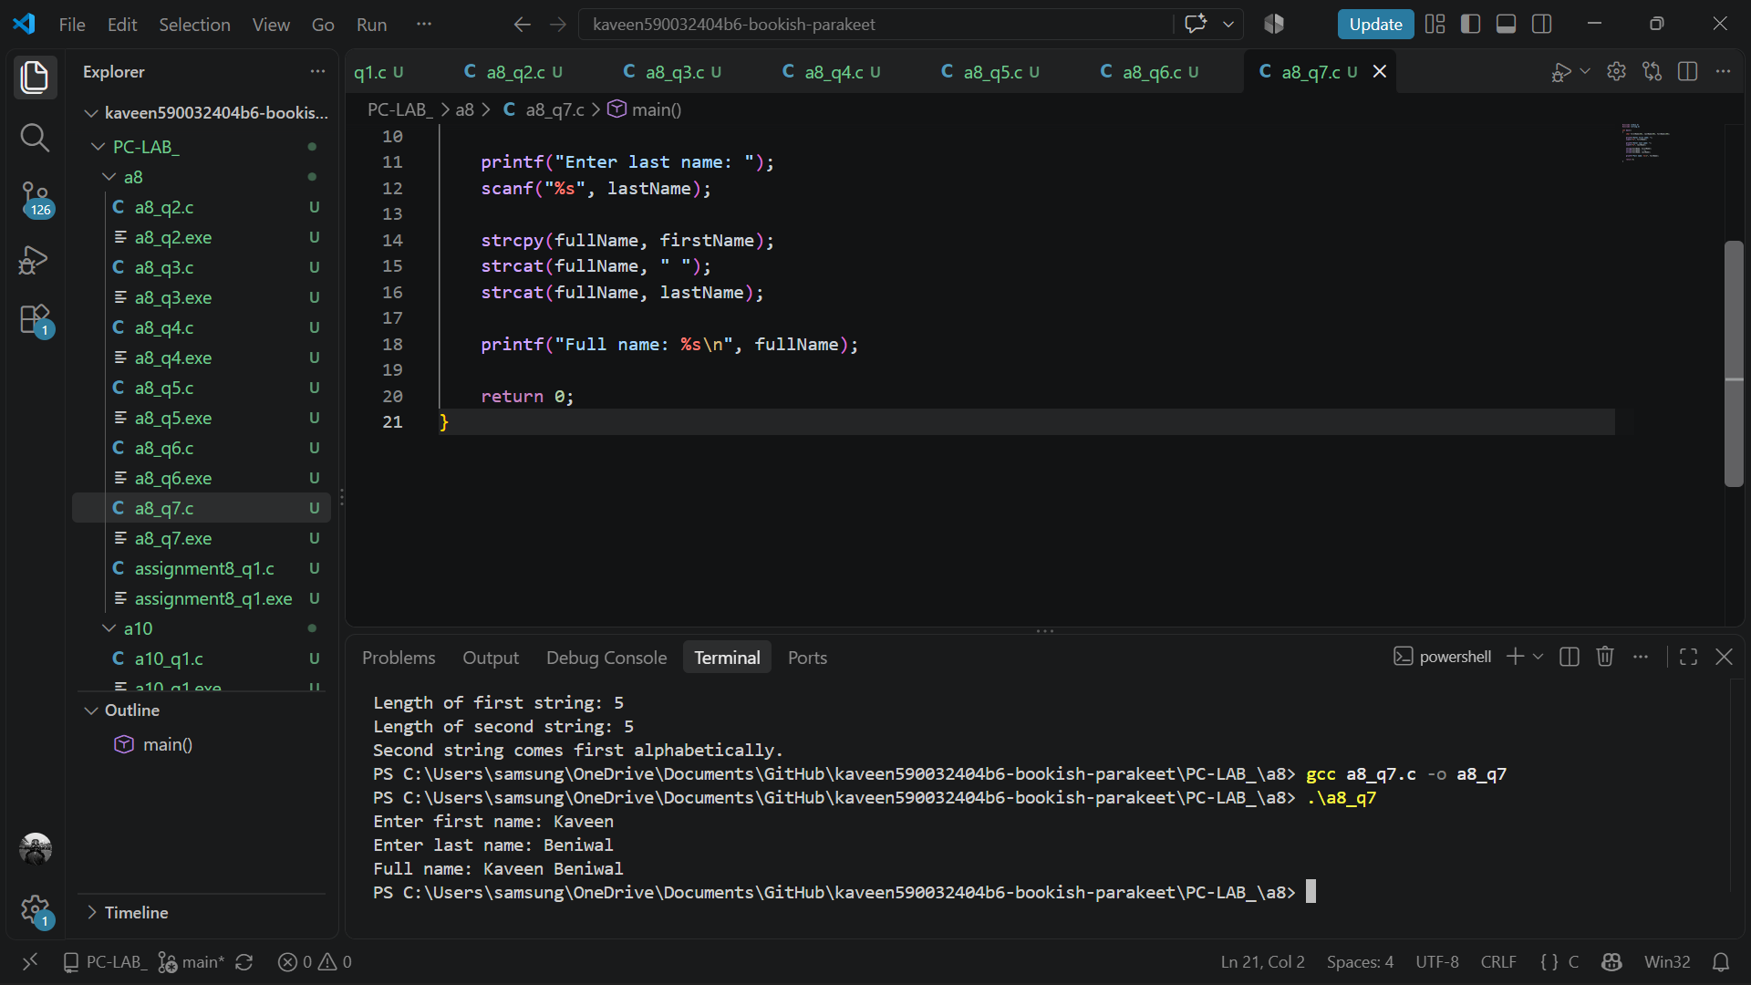
- Search for a Character
Write a C program to input a string and a character. Use strchr() to find the first occurrence of the character. If found, display its position; otherwise, display an appropriate message.
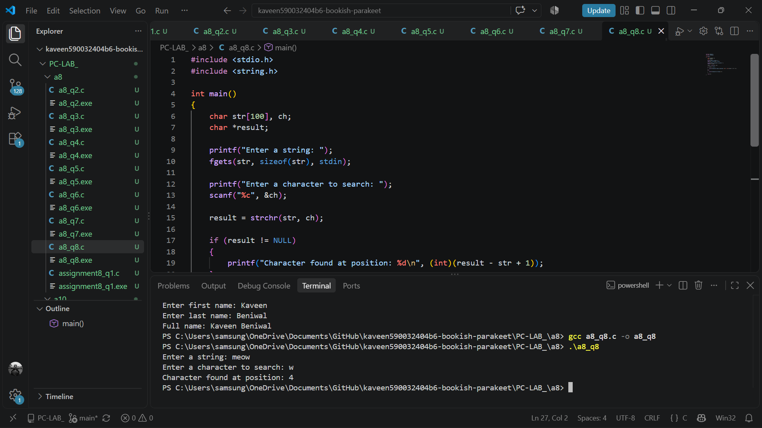
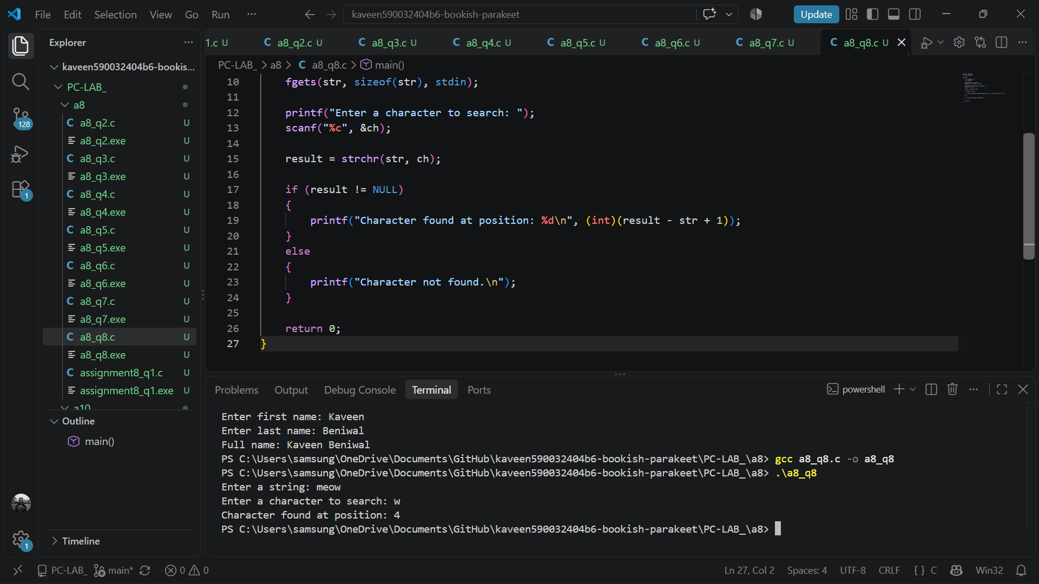

- Search for a Substring
Write a C program to input a sentence and a word. Use strstr() to determine whether the word occurs in the sentence. If found, display the starting position of its first occurrence.
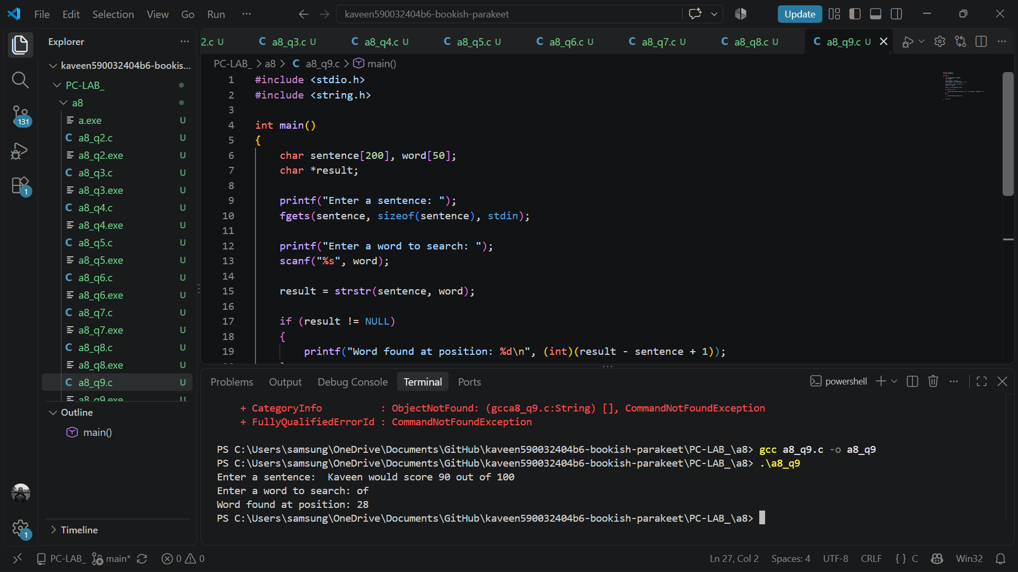
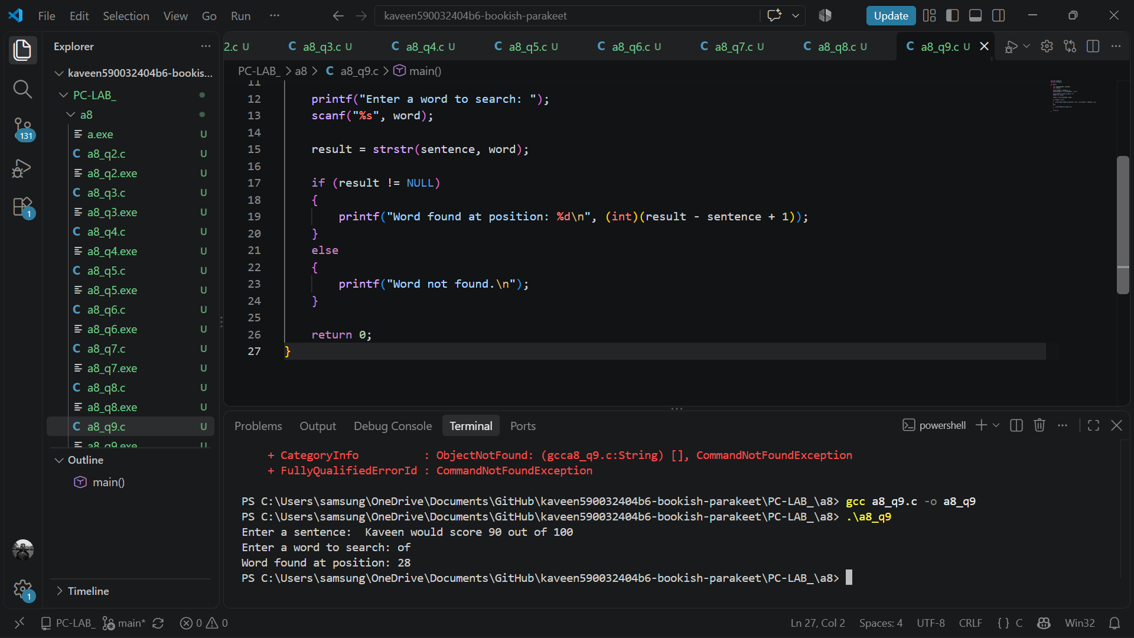

- Split a Sentence into Words
Write a C program to input a sentence and separate it into individual words using strtok(). Display each word on a separate line and count the total number of words.
